Linux Command Prompt
Example:
[root@server Images]#
- root = Username
- server = Hostname (Machine Name)
- Images = Current Directory
- # = Root User
shubham@server:~$
- $ = Normal User
- # = Root User (Administrator)

Types of Users in Linux
1. Root User
Administrator of the system.
root
Can do anything in Linux.
2. Local User
Regular user created by admin.
Examples:
ubuntu
shubham
john
Limited permissions.
3. System User
Used by services and applications.
Examples:
nginx
mysql
apache
Usually cannot log in.

sudo
Full Form: Super User Do
Runs a command with administrator privileges.
Example:
sudo apt update

su
Full Form: Substitute User (Switch User)
Used to switch from one user to another.
Example:
su root

sudo su
sudo su
- sudo = Get admin permission
- su = Switch user
Result:
root@server:~#
You become the root user.

pwd
Full Form: Print Working Directory
Shows your current location in Linux.
Example:
pwd
Output:
/home/shubham

Command Syntax
command [option] [argument]
Example:
ls -l /home
- Command = ls (What to do)
- Option = -l (How to do)
- Argument = /home (On what to do)

Examples
mkdir project
- Command = mkdir
- Argument = project
ls -a
- Command = ls
- Option = -a
cp -r website /var/www/html
- Command = cp
- Option = -r
- Arguments = website, /var/www/html

Useful Commands
pwd # Show current directory
whoami # Show current user
hostname # Show machine name
tty (Teletypewriter) # Show terminal ID
ls # List files
cd # Change directory
mkdir # Create directory
rm # Delete file
cat concatenate (printing text directly to your terminal screen is its most common everyday use)
Easy Formula
Command = What to do ( mkdir rmdir cp mv is command )
Option = How to do ( Every single one of those—-r, -i, -f, -rf, and -cvf—is both an argument and an option at the exact same time. )
Argument = On what to do (The argument is the location (the folder path or file) where you want the command to do its work. )
Example:
cp -r website /var/www/html
- What to do? → Copy (cp)
- How to do? → Recursive (-r)
- On what? → website → /var/www/html
# who am i : ( shows the username, time, and terminal details of the person who originally opened the window. Basically it shows every users that are currently logged in. If raju logs into your computer from another computer (using a remote connection tool like SSH), then typing who am i will successfully show raju on the screen. )
# w command ( does the exact same work as who am i, but it is much better and actually works perfectly on your screen )
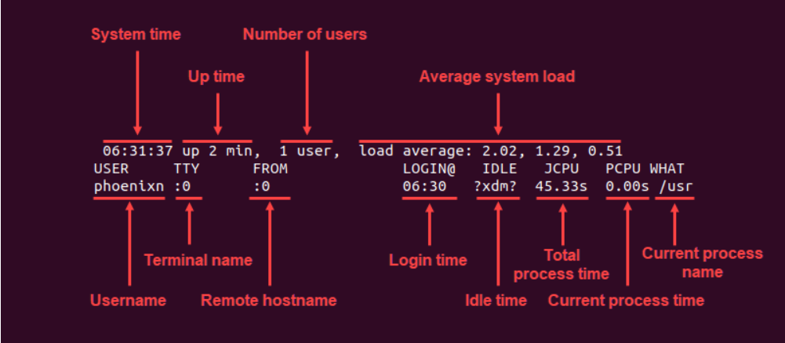
IMP
Some commands if doesn’t works it doesn’t mean it not work it could be not installed in your system
lscpu : The lscpu command stands for "List CPU". It gathers and displays detailed information about the CPU (processor) architecture of your Linux system
free : The free command in Linux Ubuntu tells you how much RAM (memory) your computer is using
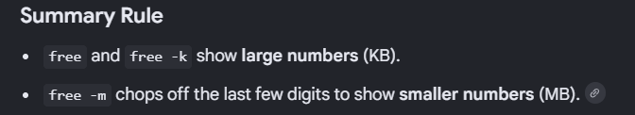
The free -g command shows your RAM usage in Gigabytes (GB).
The free -h command stands for "Human-readable" format.
Uname: shows kernel name
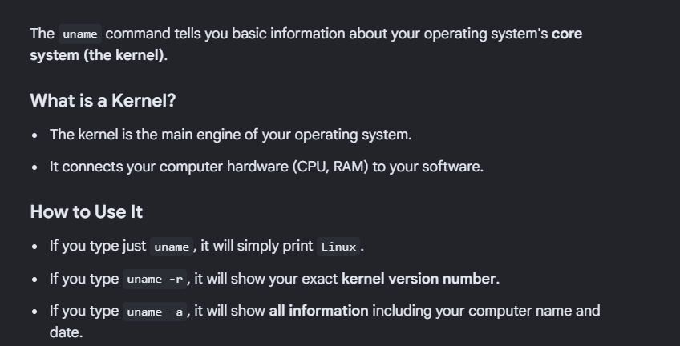Clear : The clear command simply wipes your screen clean of all old text.
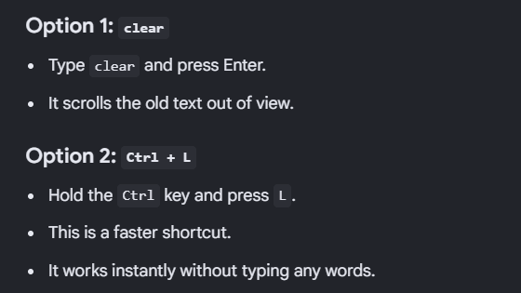

cat /etc/os-release : command shows you the exact name and version of your Linux operating system.

date:
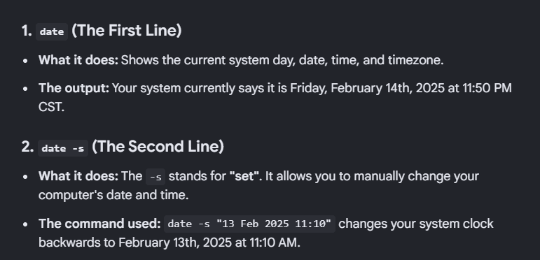
man:
The man command is a digital help button for your terminal. [1]
It stands for "manual."
Cal:
The cal command shows a simple calendar directly in your terminal.
Cal 2026 means it shows full years calendar of 2026
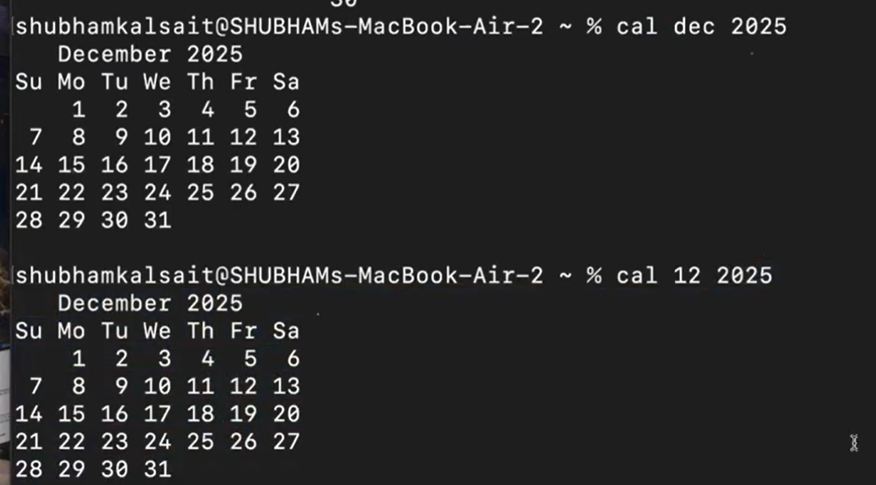
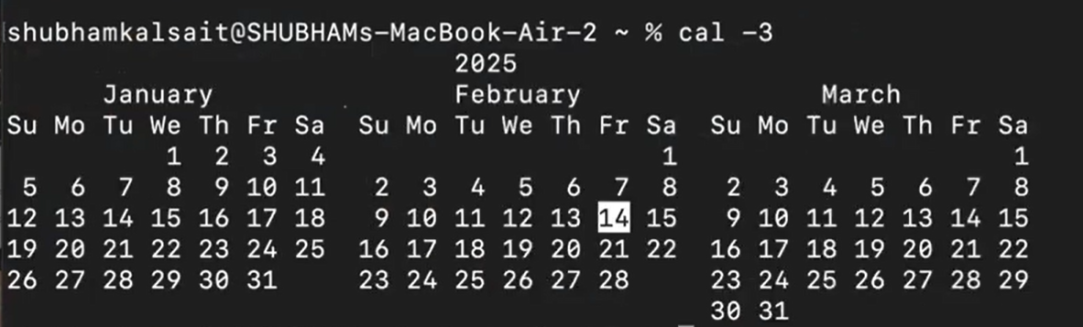
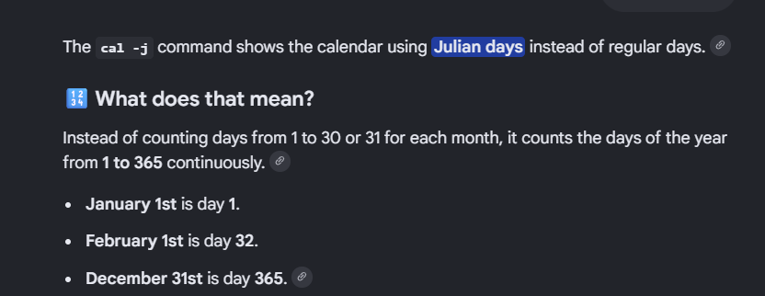
Poweroff labex
